Hursh Desai

**Decision Models and Analytics**

**Assignment 5 Report**

**Problem:** **Retirement Planning**

Assume an investment advisor, Roy Dodson, is assisting a widowed client in determining a sustainable retirement withdrawal. The client is a 59 year-old woman who turns 60 in two months. She has $1,000,000 in a tax-deferred retirement account that will be the primary source of her retirement income. Roy has designed a portfolio for his client with returns he expects to be normally distributed with a mean of 8% and standard deviation of 2%. Withdrawals will be made at the beginning of each year on the client’s birthday.

Roy assumes that the inflation rate will be 3%, based on long-term historical data. So if her withdrawal at the beginning of the first year is $40,000, her inflation-adjusted withdrawal at the beginning of the second year will be $41,200, and third year’s withdrawal will be $42,436, and so on.

To account for this uncertainty in the client’s age at death, Roy would like to model the client’s remaining life expectancy as a random variable between 0 and 50 years that follows a lognormal distribution with a mean of 20 and standard deviation of 10 (rounded to the nearest integer). In consultation with his client, he also wants to limit the chance that she will run out of money before her death to a maximum of 5%.

**Questions:**

1. If Roy advise his client to withdraw $ 60,000 on her 60th birthday, what is the probability that she will run out of money before her death?
2. What is the maximum amount she should withdraw on her 60th birthday?

**Solution:**

Excel File: Assignment 5.xlsx

If Roy advises his client to withdraw $60,000 on her 60th birthday, the probability that she will run out of money before her death is approximately 9%. The maximum amount she should withdraw on her 60th birthday is $55,790.

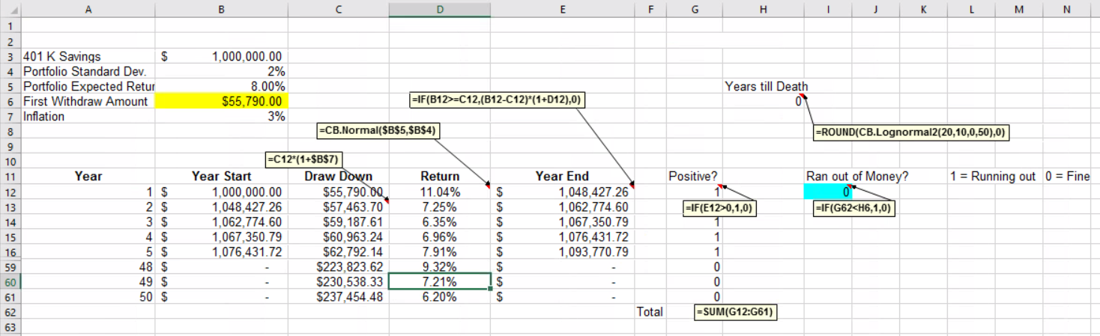

1 = Running out of money before she dies 0 = Not running out of money before she dies

If she withdraws $60,000 on her 60th birthday the probability she runs out before she dies is 9%.

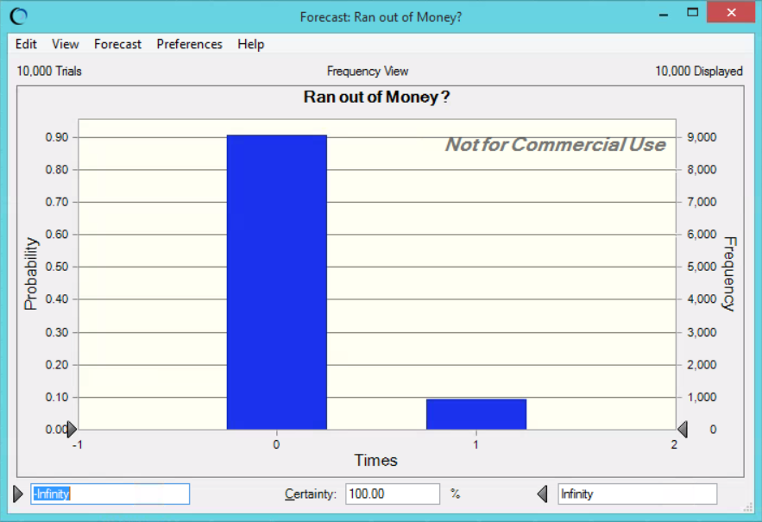

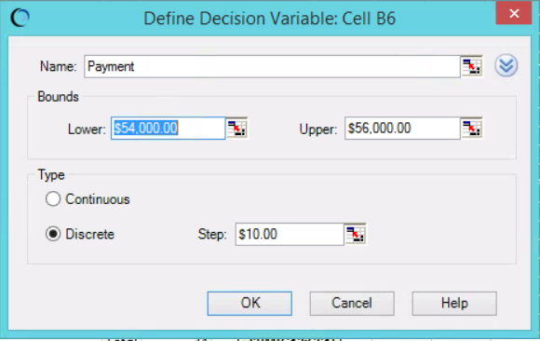

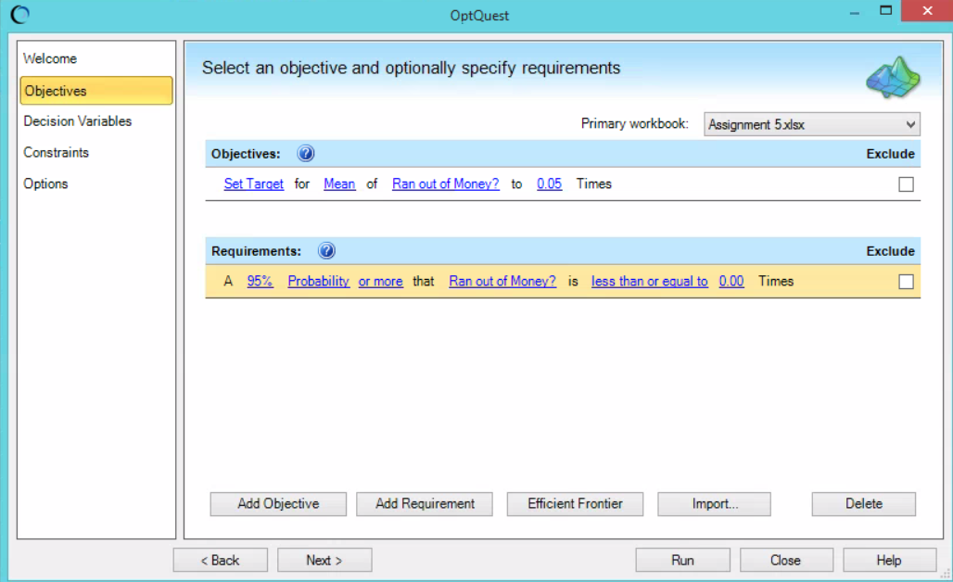

**Problem:** **Airline Reservations with Overbooking**

Transcontinental Airlines has a daily flight from San Francisco to Chicago. There are 140 coach seats and 10 business seats available. The profit per seat sold is $300 and $1000 for coach and business seats respectively.

Demand is uniformly distributed between 2 and 18 for business seats and between 100 and 220 seats for coach seats. This is a nonrefundable fare, so no-shows forfeit the entire fare. Each customer has an 80% probability to show up for his or her flight.

If we overbook this flight and have to deny boarding to a passenger, the total cost to Transcontinental will be $500 per coach passenger and $2000 per business passenger. However, in case a coach passenger needs to be bumped, if there are available seats in business class, we can upgrade customers from coach at no cost. Note that business customers cannot be downgraded to coach.

**Questions:**

Determine the overbooking limit for each customer class.

**Solution:**

Excel File: Assignment 5.xlsx

The optimal overbooking limit for coach class should be 180 seats and for business class it should be 13.

